Lesson 13.1 Study Guide: Genes and Variation: (Read Ch. 13.1; pgs. 370-374)
Reading tool: Use structure Use the headings and bulleted lists below to help understand the information.
What distinguishes and defines each of the list items from each other?

Genetics Joins Evolutionary Theory
- Define Species:
A population of physically similar, interbreeding organism that don’t interbreed with other groups

- Define Population:
A group of individuals of the same species that mate and produce offspring

- Define Gene pool:
All the genes present in a population, including ALL alleles for each gene. (gene = eye color; allele = variation of eye color)
Define Allele Frequency:
The # of times an allele occurs in a gene pool, as a percent of total occurrence.

- Genotype vs. Phenotype:
An individual's genotype (allele combo) together with environment during its lifetime produces its phenotype (appearance)

Visual Reading Tool: Allele frequencies
A homozygous black mouse has two alleles for black fur. A heterozygous black mouse has one allele for black fur and one allele for brown fur. A homozygous brown mouse has two alleles for brown fur.
In the diagram below, each rectangle represents one mouse with two alleles for fur color. Using the color copy posted to COLOR the Black and Brown alleles, figure out the allele frequencies for both the black and brown alleles.
Allele frequency = # of an allele ÷ total number of alleles x 100
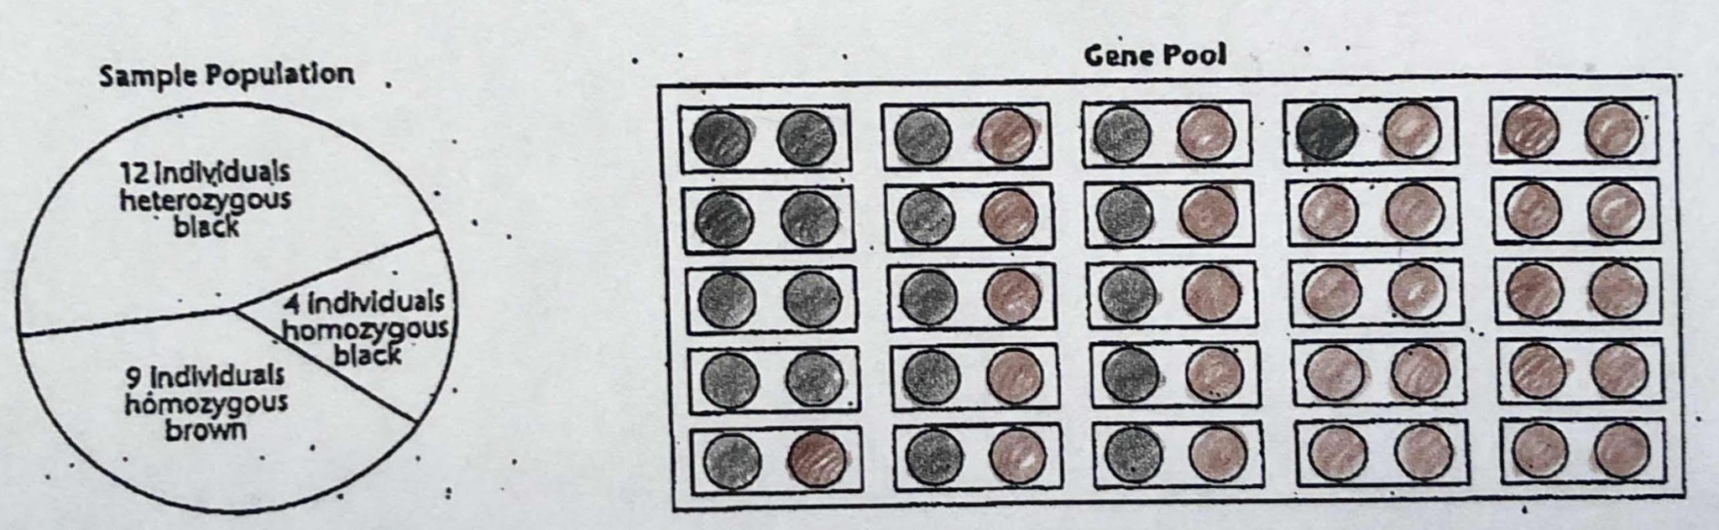

- What is the allele frequency of the black allele? __20/50 x 100 = 40%__; brown allele? __30/50 x 100 = 60%__
- True or False: Dominant alleles always have the highest percent of allele frequency. __False__

Sources of Genetic Variation
- Genetic Recombination during sexual reproduction: (you should include meiosis and crossing over)
Increases variety as homologous chromosomes are randomly shuffled into gametes (sperm or egg) and crossing over of genes during meiosis occurs at random.

- Mutations:
A (in)heritable change in genetic information from normal

- Lateral Gene Shuffle:
The passing of genes from one organism to another (not offspring) Bacterial conjugation (Swapping plasmids) is the only example of this.

- When do mutations matter in evolution?
ONLY if they can be passed on from one generation to the next.

So, where do mutations have to occur?
Mutations must occur in the gametes to go from one generation to the next

Natural Selection on a single gene trait
Read pg. 376 and the table below is figure 13-5 found on pg. 376

A color mutation occurred in a lizard population, causing red and black scales. The table below (also shown on pg. 376) shows how the population changed over the next 30 generations.
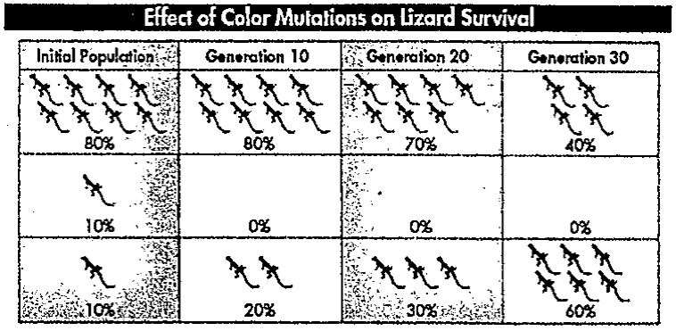
- What is happening to the allele frequency of the light
color allele?
The frequency of the light color allele is decreasing

- What is happening to the allele frequency of the dark
color allele?
The frequency of the dark color allele is increasing.

- Is the red allele mutation favorable or unfavorable? WHY?
Unfavorable. After 1 generation it is no longer seen.

- Reading pg. 376 in the text, what might cause the change shown in the table?
Black (darker) coloration might enable those individuals to warm-up and allow them to be more active in finding food
and avoiding predators than the lighter brown lizards. This might be due to less vegetation which means more sun available.

- Predict: What will the lizard population look like after 40 generations?
The darker coloration may increase to 70% or more in allele frequency while the lighter color may decrease to 30%

- Infer: Why is it that natural selection acts on phenotype, NOT genotype, of an organism?
Because an organism's physical and behavioral characteristics (phenotype) interacts with the environment

